**Software installation guide**

Written by: Javier Andrial

**YouTube Installation Video:** https://youtu.be/NPH2EDRwcOc?list=PLG3lylzOg8FhmieFWVdncBnC6AdDE2Fdm

Once you’re given a VM with login credentials, ssh into the VM with putty

Now that you’re logged into your VM you’ll need to install LAMP (Linux Apache MySQL PHP)

**How to Install LAMP**

sudo apt-get install apache2 php5 libapache2-mod-php5 mysql-server php5-mysql

sudo mysql_install_db

sudo /usr/bin/mysql_secure_installation

**Create a Vhost**

When asked to create a Vhost. Create a Vhost

**[Additional steps]**

Copy marketsim.conf to /etc/apache2/sites-enabled/

You can find marketsim.conf in Server Stuff folder

sudo mkdir /srv/marketsim

sudo mkdir /srv/marketsim/www

sudo service apache2 restart

sudo nano /etc/apache2/sites-enabled/marketsim.conf

Change Servername to marketsim-dev.cis.fiu.edu

Ctrl+o, ctrl+x

Sudo service apache2 restart

sudo nano /etc/apache2/apache2.conf

Hit down arrow key for a bit

Uncomment:

<Directory /srv/>

Options FollowSymLinks

AllowOverride None

Require all granted

</Directory>

Ctrl+o, ctrl+x

Sudo service apache2 restart

Sudo chown username /srv/marketsim/www/

Sudo chown username /srv/marketsim/

Sudo chown username /srv/

**How to restore/back up the database**

Backing up a single database

shell> mysqldump db_name > backup-file.sql

Restoring or loading the database

shell> mysql db_name < backup-file.sql

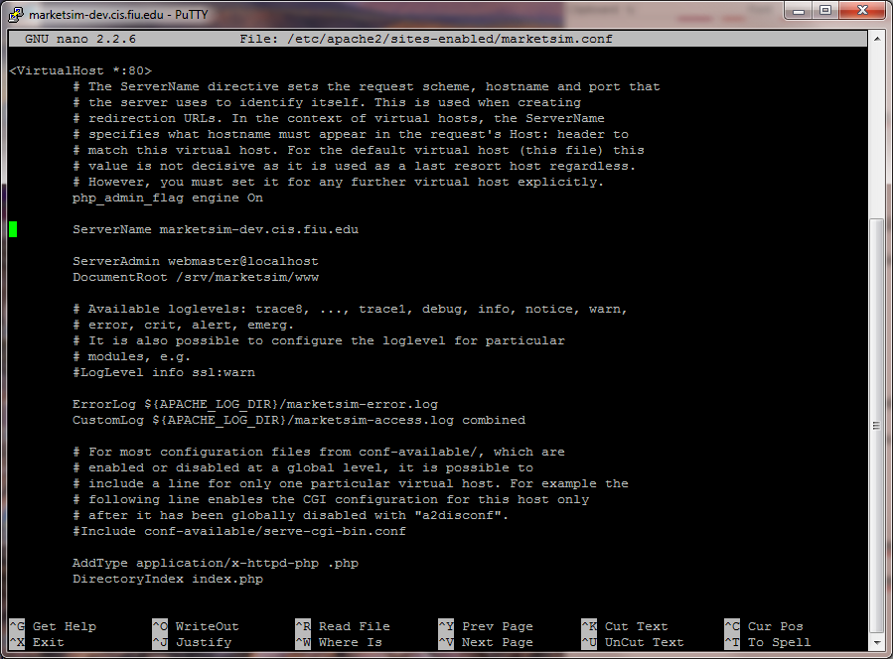

Figure 1 : sudo nano /etc/apache2/sites-enabled/marketsim.conf

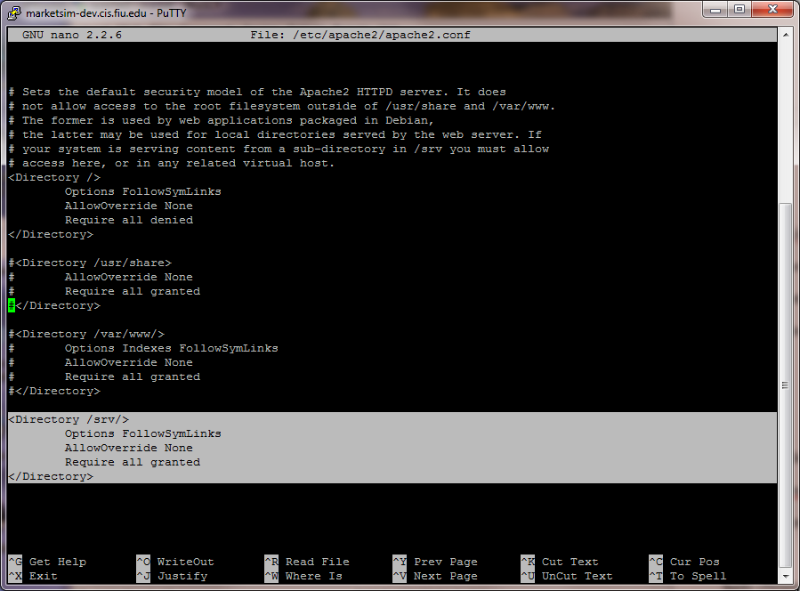

Figure 2: uncomment apache2/apache2.conf